Introduction
Cyber security is a broad topic that covers a wide range of subjects, but few of those are as ubiquitous as databases. Whether you’re working on securing a web application, working in a SOC and using a SIEM, configuring user authentication/access control, or using malware analysis/threat detection tools (the list goes on), you will in some way be relying on databases. For example, on the offensive side of security, it can help us better understand SQL vulnerabilities, such as SQL injections, and create queries that help us tamper or retrieve data within a compromised service. On the other hand, on the defensive side, it can help us navigate through databases and find suspicious activity or relevant information; it can also help us better protect a service by implementing restrictions when needed.
Because databases are ubiquitous, it is important to understand them, and this room will be your first step in that direction. We’ll go through the basics of databases, covering key terms, concepts and different types before getting to grips with SQL.
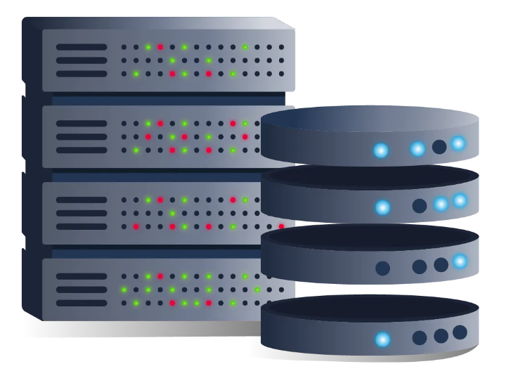

Databases 101

Introducing Databases
Okay, so you’ve been told just how important they are. Now, it's time to understand what they are in the first place. As mentioned in the introduction, databases are so ubiquitous that you very likely interact with systems that are using them. Databases are an organised collection of structured information or data that is easily accessible and can be manipulated or analysed. That data can take many forms, such as user authentication data (such as usernames and passwords), which are stored and checked against when authenticating into an application or site (like TryHackMe, for example), user-generated data on social media (Like Instagram and Facebook) where data such as user posts, comments, likes etc are collected and stored, as well as information such as watch history which is stored by streaming services such as Netflix and used to generate recommendations.
I’m sure you get the point: databases are used extensively and can contain many different things. It’s not just massive-scale businesses that use databases. Smaller-scale businesses, when setting up, will almost certainly have to configure a database to store their data. Speaking of kinds of databases, let’s take a look now at what those are.

Different Types of Databases
Now it makes sense that something is used by so many and for (relatively) so long that there would be multiple types of implementations. There are quite a few different types of databases that can be built, but for this introductory room, we are going to focus on the two primary types: relational databases (aka SQL) vs non-relational databases (aka NoSQL).
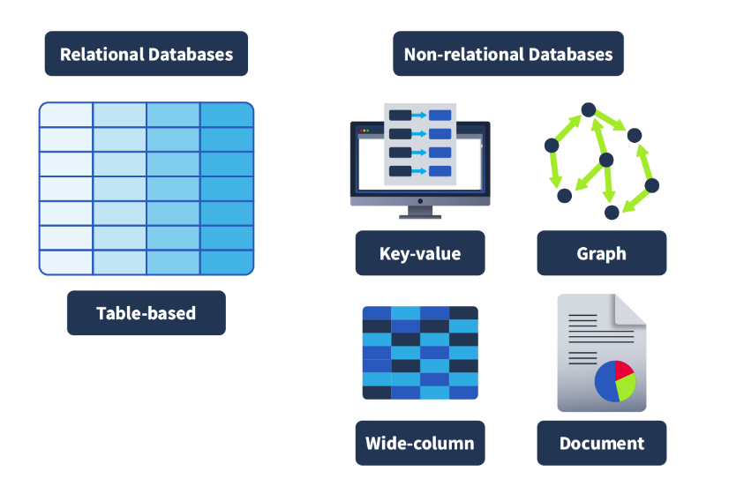
Relational databases: Store structured data, meaning the data inserted into this database follows a structure. For example, the data collected on a user consists of first_name, last_name, email_address, username and password. When a new user joins, an entry is made in the database following this structure. This structured data is stored in rows and columns in a table (all of which will be covered shortly); relationships can then be made between two or more tables (for example, user and order_history), hence the term relational databases.
Non-relational databases: Instead of storing data the above way, store data in a non-tabular format. For example, if documents are being scanned, which can contain varying types and quantities of data, and are stored in a database that calls for a non-tabular format. Here is an example of what that might look like:
{
_id: ObjectId("4556712cd2b2397ce1b47661"),
name: { first: "Thomas", last: "Anderson" },
date_of_birth: new Date('Sep 2, 1964'),
occupation: [ "The One"],
steps_taken : NumberLong(4738947387743977493)
}

In terms of what database should be chosen, it always comes down to the context in which the database is going to be used. Relational databases are often used when the data being stored is reliably going to be received in a consistent format, where accuracy is important, such as when processing e-commerce transactions. Non-relational databases, on the other hand, are better used when the data being received can vary greatly in its format but need to be collected and organised in the same place, such as social media platforms collecting user-generated content.

Tables, Rows and Columns
Now that we’ve defined the two primary types of databases, we’ll focus on relational databases. We’ll start by explaining tables, rows, and columns. All data stored in a relational database will be stored in a table; for example, a collection of books in stock at a bookstore might be stored in a table named “Books”.
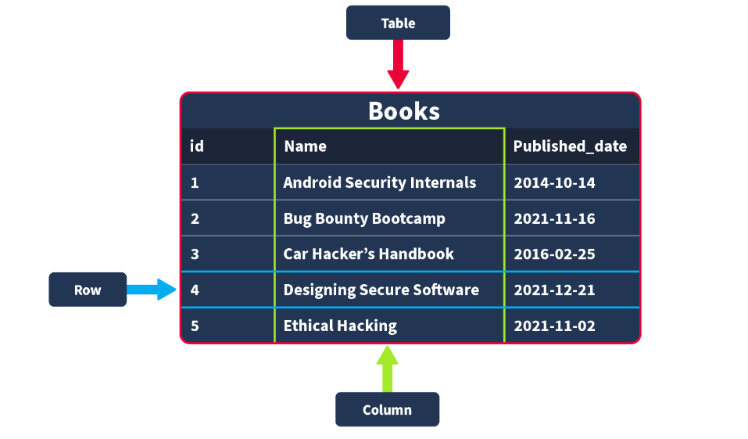
When creating this table, you would need to define what pieces of information are needed to define a book record, for example, “id”, “Name”, and “Published_date”. These would then be your columns; when these columns are being defined, you would also define what data type this column should contain; if an attempt is made to insert a record into a database where the data type does not match, it is rejected. The data types that can be defined can vary depending on what database you are using, but the core data types used by all include Strings (a collection of words and characters), Integers (numbers), floats/decimals (numbers with a decimal point) and Times/Dates.
Once a table has been created with the columns defined, the first record would be inserted into the database, for example, a book named “Android Security Internals” with an id of “1” and a publication date of “2014-10-14”. Once inserted, this record would be represented as a row.

Primary and Foreign Keys
Once a table has been defined and populated, more data may need to be stored. For instance, we want to create a table named “Authors” that stores the authors of the books sold in the store. Here is a very clear example of a relationship. A book (stored in the Books table) is written by an author (stored in the Authors table). If we wanted to query for a book in our story but also have the author of that book returned, our data would need to be related somehow; we do this with keys. There are two types of keys:
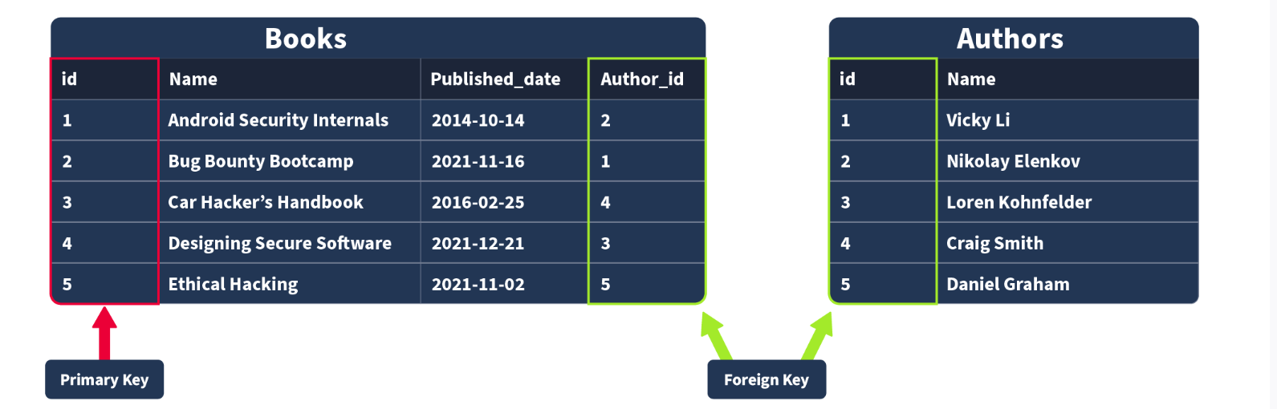

Primary Keys: A primary key is used to ensure that the data collected in a certain column is unique. That is, there needs to be a way to identify each record stored in a table, a value unique to that record and is not repeated by any other record in that table. Think about matriculation numbers in a university; these are numbers assigned to a student so they can be uniquely identified in records (as sometimes students can have the same name). A column has to be chosen in each table as a primary key; in our example, “id” would make the most sense as an id has been uniquely created for each book where, as books can have the same publication date or (in rarer cases) book title. Note that there can only be one primary key column in a table.
Foreign Keys: A foreign key is a column (or columns) in a table that also exists in another table within the database, and therefore provides a link between the two tables. In our example, think about adding an “author_id” field to our “Books” table; this would then act as a foreign key because the author_id in our Books table corresponds to the “id” column in the author table. Foreign keys are what allow the relationships between different tables in relational databases. Note that there can be more than one foreign key column in a table.

SQL
What is SQL?
Now, all of this theoretically sounds great, but in practice, how do databases work? How would you go and make your first table and populate it with data? What would you use? Databases are usually controlled using a Database Management System (DBMS). Serving as an interface between the end user and the database, a DBMS is a software program that allows users to retrieve, update and manage the data being stored. Some examples of DBMSs include MySQL, MongoDB, Oracle Database and Maria DB.
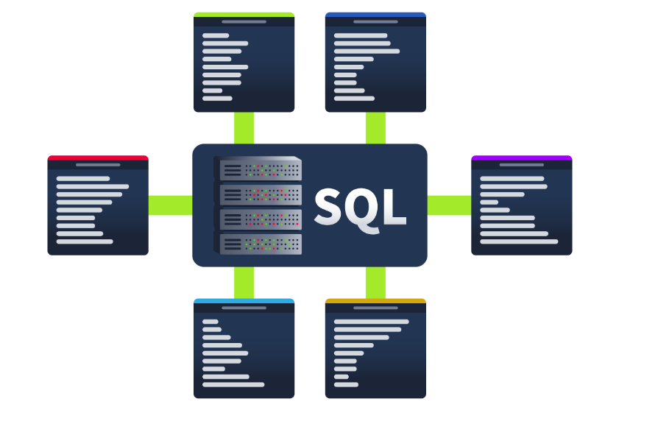
The interaction between the end user and the database can be done using SQL (Structured Query Language). SQL is a programming language that can be used to query, define and manipulate the data stored in a relational database.
The Benefits of SQL and Relational Databases
SQL is almost as ubiquitous as databases themselves, and for good reason. Here are some of the benefits that come with learning and using to use SQL:
- It's fast: Relational databases (aka those that SQL is used for) can return massive batches of data almost instantaneously due to how little storage space is used and high processing speeds.

- Easy to Learn: Unlike many programming languages, SQL is written in plain English, making it much easier to pick up. The highly readable nature of the language means users can concentrate on learning the functions and syntax.

- Reliable: As mentioned before, relational databases can guarantee a level of accuracy when it comes to data by defining a strict structure into which data sets must fall in order to be inserted.

- Flexible: SQL provides all kinds of capabilities when it comes to querying a database; this allows users to perform vast data analysis tasks very efficiently.

Getting Hands ON

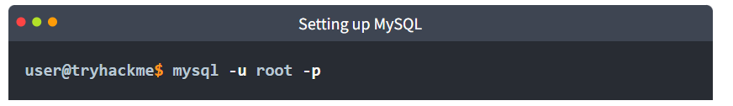
Once prompted for the password, enter:
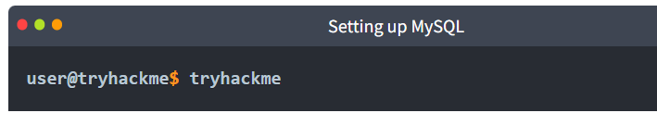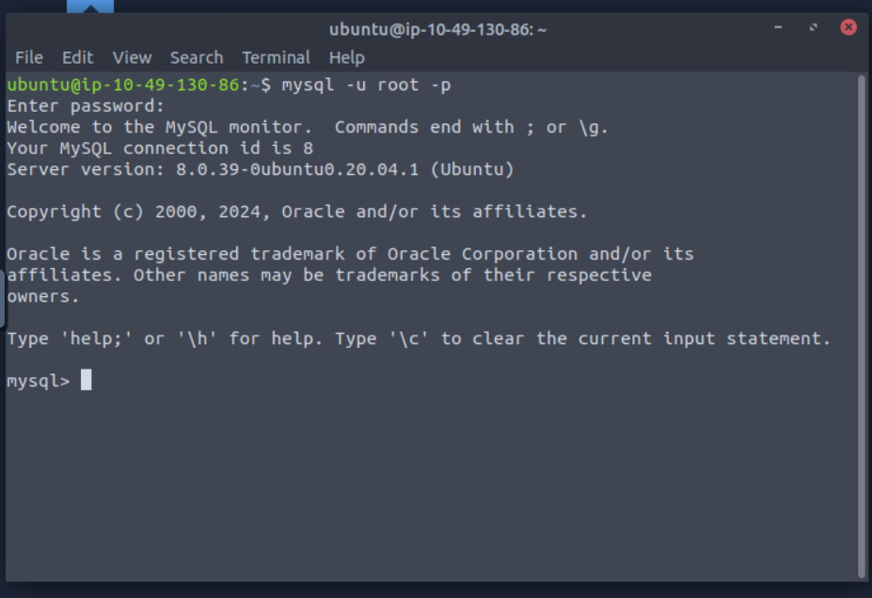

Database and Table Statements

Time to Learn
Now, the fun part! It's time to start learning SQL and how to use it to interact with databases. In this task, we’re going to start by learning to use database and table statements. After all, it’s these statements we need to initially create our databases/tables and get started.

Database Statements
CREATE DATABASE
If a new database is needed, the first step you would take is to create it. This can be done in SQL using the CREATE DATABASE statement. This would be done using the following syntax: 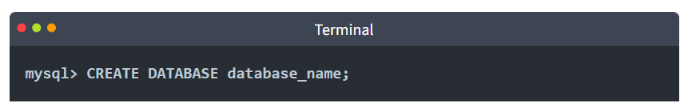
Run the following command to create a database named thm_bookmarket_db: 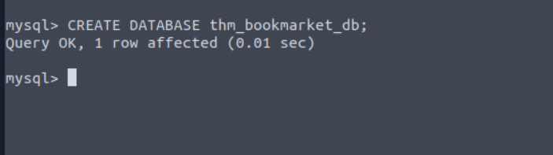
SHOW DATABASES
Now that we have created a database, we can view it using the SHOW DATABASES statement. The SHOW DATABASES statement will return a list of present databases. Run the statement as follows:
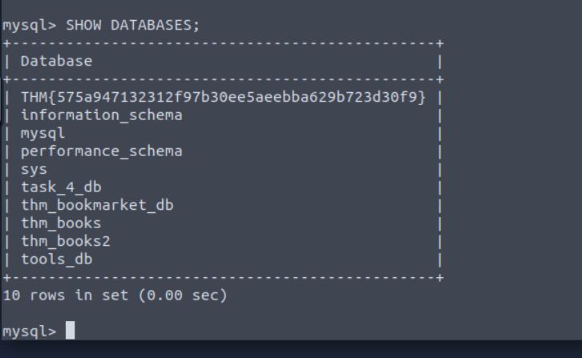
In the returned list, you should see the database you have just created and some databases that are included by default (mysql, information_scheme, performance_scheme and sys), which are used for various purposes that enable mysql to function. Also present are various tables needed for this lesson.
USE DATABASE
Once a database is created, you may want to interact with it. Before we can interact with it, we need to tell mysql which database we would like to interact with (so it knows which database to run subsequent queries against). To set the database we have just created as the active database, we would run the USE statement as follows (make sure to run this on your machine):
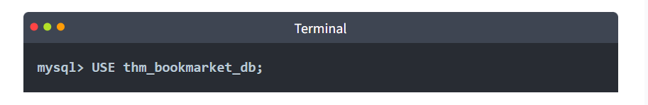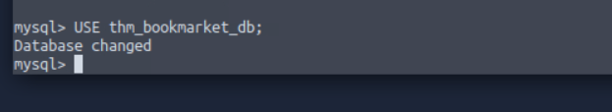
DROP DATABASE
Once a database is no longer needed (maybe it was created for test purposes, or is no longer required), it can be removed using the DROP statement. To remove a database, we would use the following statement syntax (although, in our case, we want to keep our database, so no need to run this one yourself!):
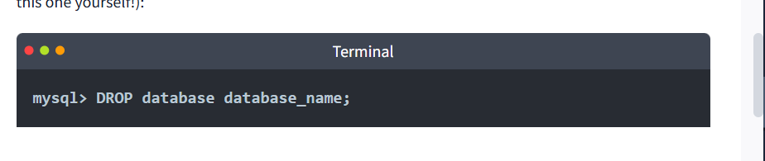

Table Statements
Now that you can create, list, use, and remove databases, it's time to examine how we would populate those databases with tables and interact with those tables.
CREATE TABLE
Following the logic of the database statements, creating tables also uses a CREATE statement. Once a database is active (you have run the USE statement on it), a table can be created within it using the following statement syntax:
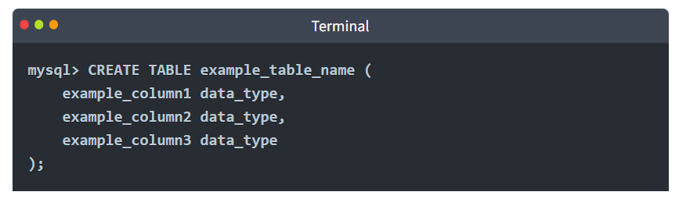
As you can see, there is a little more involved here. In the Databases 101 task, we covered how and when a table is created; it must be decided what columns will make up a record in that table, as well as what data type is expected to be contained within that column. That is what is represented by this syntax here. In the example, there are 3 example columns, but SQL supports many (over 1000). Let's try populating our thm_bookmarket_db with a table using the following statement:
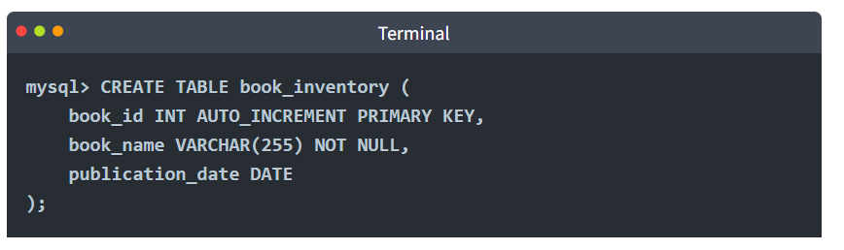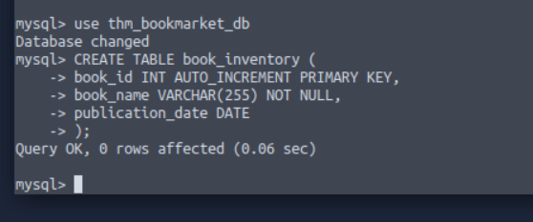
This statement will create a table book_inventory with three columns: book_id, book_name and publication_date. book_id is an INT (Integer) as it should only ever be a number, AUTO_INCREMENT is present, meaning the first book inserted would be assigned book_id 1, the second book inserted would be assigned a book_id of 2, and so on. Finally, book_id is set as the PRIMARY KEY as it will be the way we uniquely identify a book record in our table (and a primary must be present in a table).
Book_name has the data type VARCHAR(255), meaning it can use variable characters (text/numbers/punctuation) and a limit of 255 characters is set and NOT NULL, meaning it cannot be empty (so if someone tried to insert a record into this table but the book_name was empty it would be rejected. Publication_date is set as the data type DATE.
SHOW TABLES
Just as we can list databases using a SHOW statement, we can also list the tables in our currently active database (the database on which we last used the USE statement). Run the following command, and you should see the table you have just created:
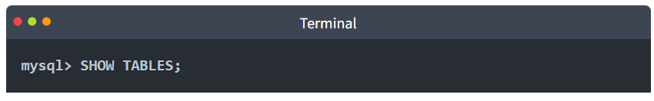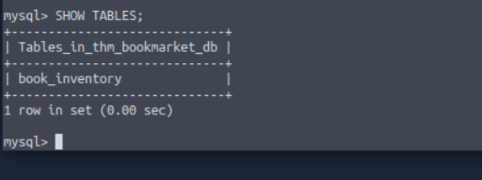

DESCRIBE
If we want to know what columns are contained within a table (and their data type), we can describe them using the DESCRIBE command (which can also be abbreviated to DESC). Describe the table you have just created using the following command:
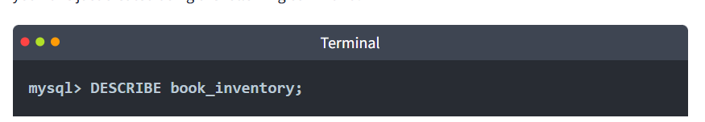
This will give you a detailed view of the table like so:
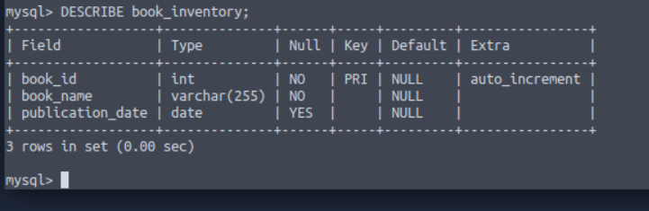
ALTER
Once you have created a table, there may come a time when your need for the dataset changes, and you need to alter the table. This can be done using the ALTER statement. Let’s now imagine that we have decided that we actually want to have a column in our book inventory that has the page count for each book. Add this to our table using the following statement:
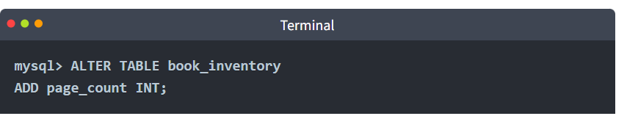
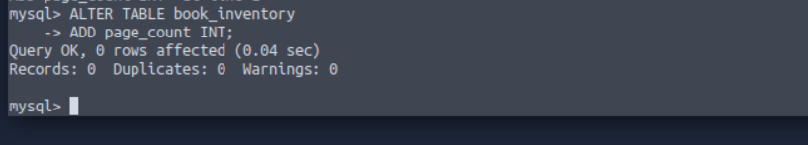
The ALTER statement can be used to make changes to a table, such as renaming columns, changing the data type in a column or removing a column.
DROP
Similar to removing a database, you can also remove tables using the DROP statement. We don’t need to do this, but the syntax you would use for this is:
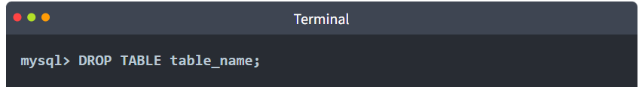

PRACTICAL:
Using the statement you've learned to list all databases, it should reveal a database with a flag for a name; what is it?
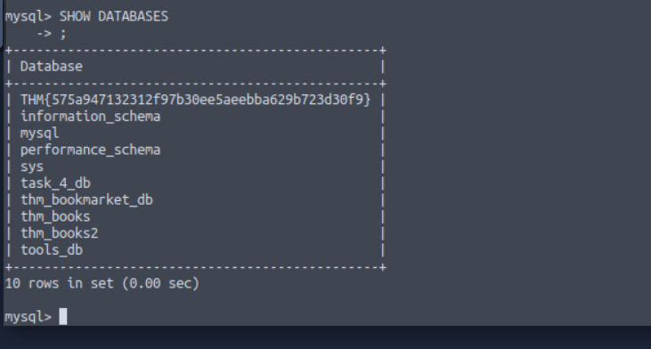
In the list of available databases, you should also see the task_4_db database. Set this as your active database and list all tables in this database; what is the flag present here?
SHOW TABLES;

CRUD Operations

CRUD
CRUD stands for Create, Read, Update, and Delete, which are considered the basic operations in any system that manages data.
Let's explore all these different operations when working with MySQL. In the next two tasks, we will be using the books table that is part of the database thm_books. We can access it with the statement use thm_books;.

Create Operation (INSERT)
The Create operation will create new records in a table. In MySQL, this can be achieved by using the statement INSERT INTO, as shown below.
mysql> INSERT INTO books (id, name, published_date, description)
VALUES (1, "Android Security Internals", "2014-10-14", "An In-Depth Guide to Android's Security Architecture");

As we can observe, the INSERT INTO statement specifies a table, in this case, books, where you can add a new record; the columns id, name, published_date, and description are the records in the table. In this example, a new record with an id of 1, a name of "Android Security Internals", a published_date of "2014-10-14", and a description stating "Android Security Internals provides a complete understanding of the security internals of Android devices" was added.
Note: This operation already exists in the database so there is no need to run the query.

Read Operation (SELECT)
The Read operation, as the name suggests, is used to read or retrieve information from a table. We can fetch a column or all columns from a table with the SELECT statement, as shown in the next example.
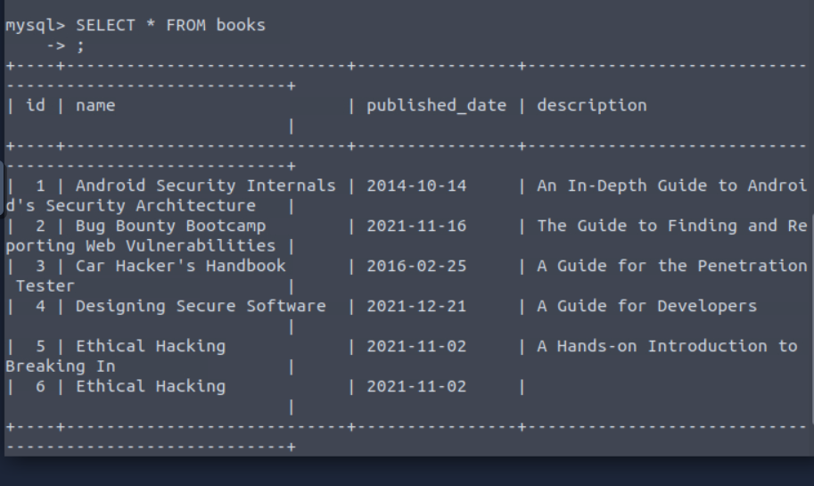
The above output SELECT statement is followed by an * symbol indicating that all columns should be retrieved, followed by the FROM clause and the table name, in this case, books.
If we want to select a specific column like the name and description, we should specify them instead of the * symbol, as shown below.

Update Operation (UPDATE)
The Update operation modifies an existing record within a table, and the same statement, UPDATE, can be used for this. 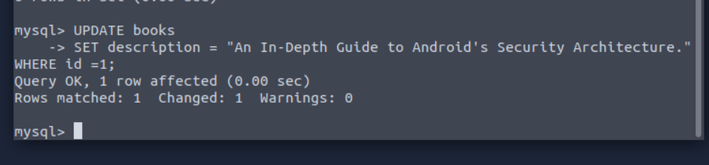

The UPDATE statement specifies the table, in this case, books, and then we can use SET followed by the column name we will update. The WHERE clause specifies which row to update when the clause is met, in this case, the one with id 1.

Delete Operation (DELETE)
The delete operation removes records from a table. We can achieve this with the DELETE statement.
Note: There is no need to run the query. Deleting this entry will affect the rest of the examples in the upcoming tasks. 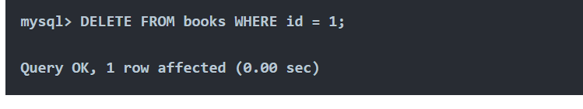Above, we can observe the DELETE statement followed by the FROM clause, which allows us to specify the table where the record will be removed, in this case, books, followed by the WHERE clause that indicates that it should be the one where the id is 1.

Summary
In summary, CRUD operations results are fundamental for data operations and when interacting with databases. The statements associated with them are listed below.
- Create (INSERT statement) - Adds a new record to the table.
- Read (SELECT statement) - Retrieves record from the table.
- Update (UPDATE statement) - Modifies existing data in the table.
- Delete (DELETE statement) - Removes record from the table.
These operations enable us to effectively manage and manipulate data within a database.

Practical:
Using the tools_db database, what is the name of the tool in the hacking_tools table that can be used to perform man-in-the-middle attacks on wireless networks? 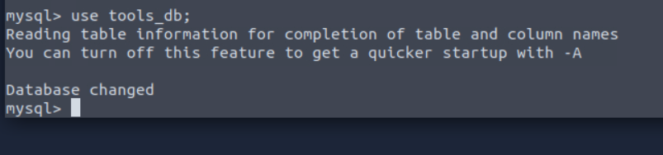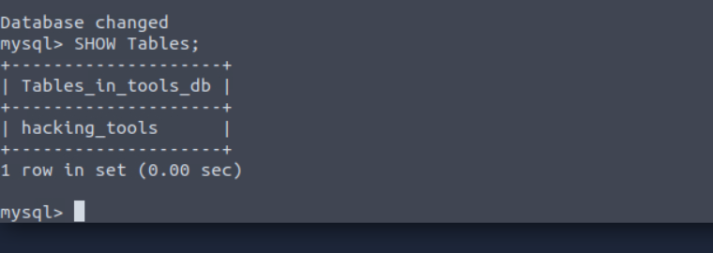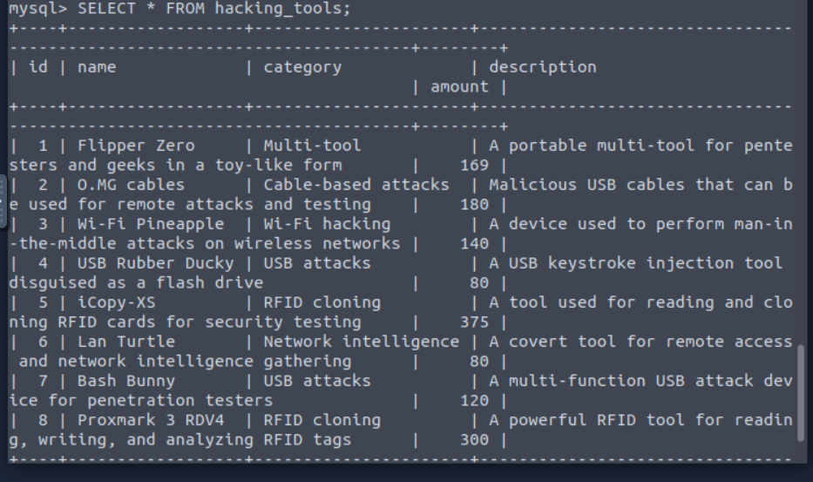

Using the tools_db database, what is the shared category for both USB Rubber Ducky and Bash Bunny? 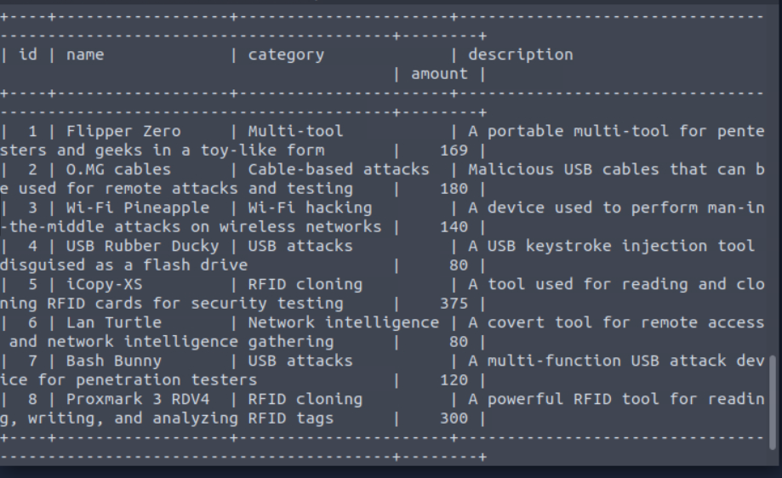

Clauses
A clause is a part of a statement that specifies the criteria of the data being manipulated, usually by an initial statement. Clauses can help us define the type of data and how it should be retrieved or sorted.
In previous tasks, we already used some clauses, such as FROM that is used to specify the table we are accessing with our statement and WHERE, which specifies which records should be used.
This task will focus on other clauses: DISTINCT, GROUP BY, ORDER BY, and HAVING.
In this task, we will continue to use the books table that is part of the database thm_books. We can access it with the statement use thm_books;.

DISTINCT Clause
The DISTINCT clause is used to avoid duplicate records when doing a query, returning only unique values.
Let's use a query SELECT * FROM books and observe the results below. 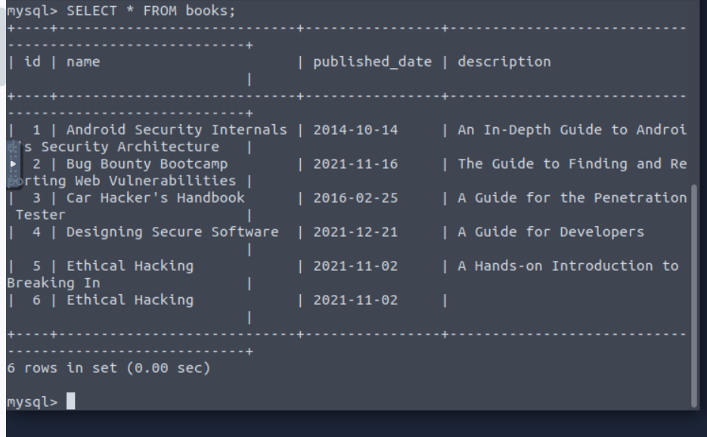
The query's output displays all the content of the table books, and the record Ethical Hacking is displayed twice. Let's perform the query again, but this time, using the DISTINCT clause. 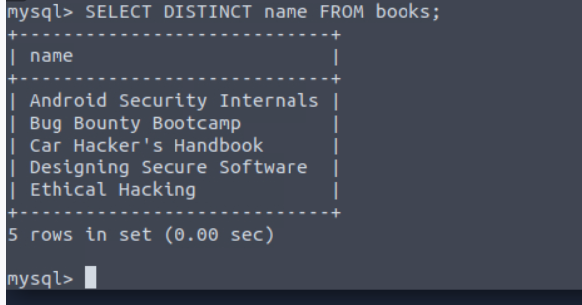
The output shows that only five rows are returned, and just one instance of the Ethical Hacking record is displayed.

GROUP BY Clause
The GROUP BY clause aggregates data from multiple records and groups the query results in columns. This can be helpful for aggregating functions.
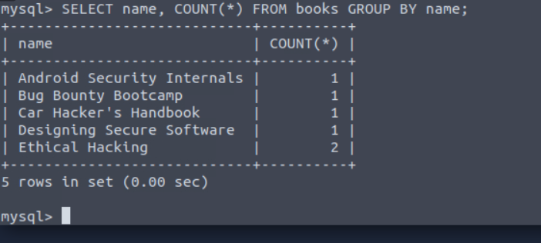
In the example above, the records on the book table are regrouped by the result of the COUNT function. We already know that Ethical hacking is listed twice, so the total count is 2, placed at the end since it is grouped by count.

ORDER BY Clause
The ORDER BY clause can be used to sort the records returned by a query in ascending or descending order. Using functions like ASC and DESC can help us to accomplish that, as shown below in the next two examples.
ASCENDING ORDER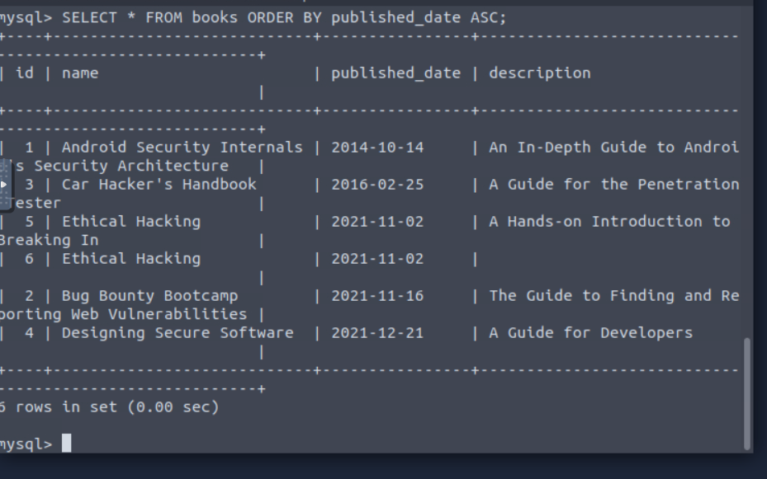
DESCENDING ORDER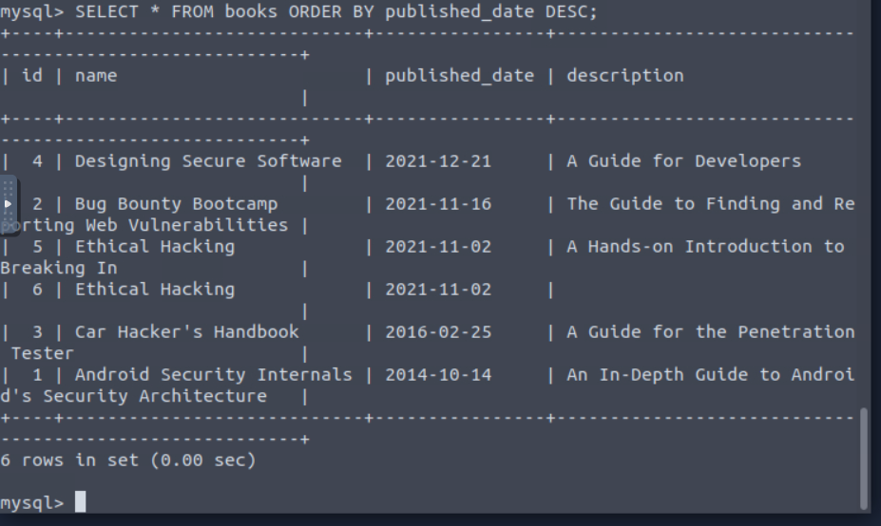
We can observe the difference when sorting by ascending order using ASC and in descending order using DESC, both using the published_date as reference.

HAVING Clause
The HAVING clause is used with other clauses to filter groups or results of records based on a condition. In the case of GROUP BY, it evaluates the condition to TRUE or FALSE, unlike the WHERE clause HAVING filters the results after the aggregation is performed. 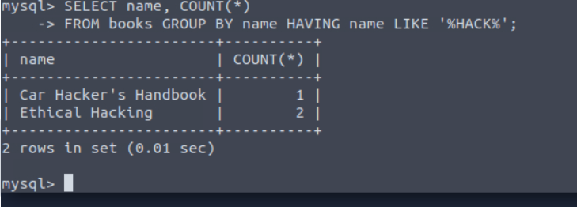
In the example above, we can observe that the query returns the books with the names that contain the word hack and the proper count, as we learned before.

Practical:
Using the tools_db database, what is the total number of distinct categories in the hacking_tools table? 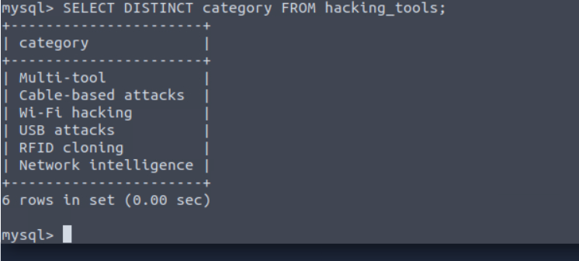
Using the tools_db database, what is the first tool (by name) in ascending order from the hacking_tools table? 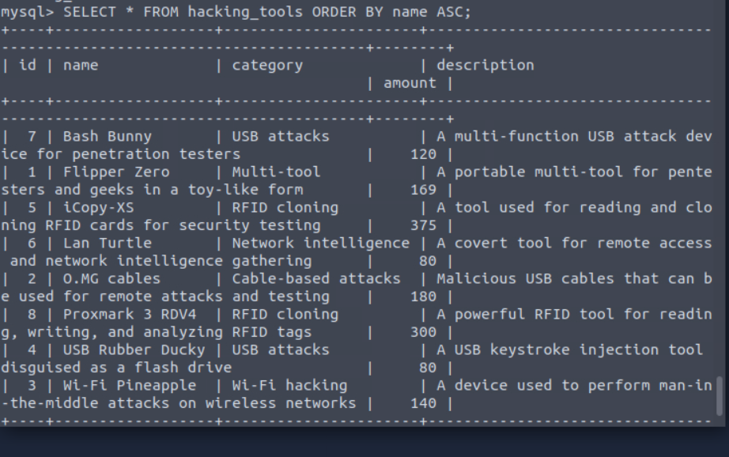
Using the tools_db database, what is the first tool (by name) in descending order from the hacking_tools table? 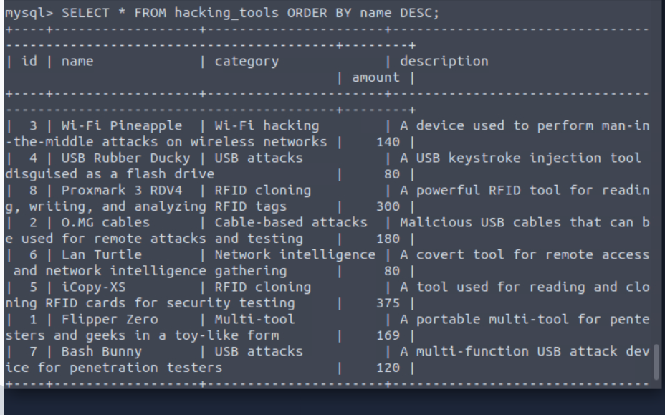

Operators
When working with SQL and dealing with logic and comparisons, operators are our way to filter and manipulate data effectively. Understanding these operators will help us to create more precise and powerful queries. In the next two tasks, we will be using the books table that is part of the database thm_books2. We can access it with the statement use thm_books2;.

Logical Operators
These operators test the truth of a condition and return a boolean value of TRUE or FALSE. Let's explore some of these operators next.

LIKE Operator
The LIKE operator is commonly used in conjunction with clauses like WHERE in order to filter for specific patterns within a column. Let's continue using our DataBase to query an example of its usage. 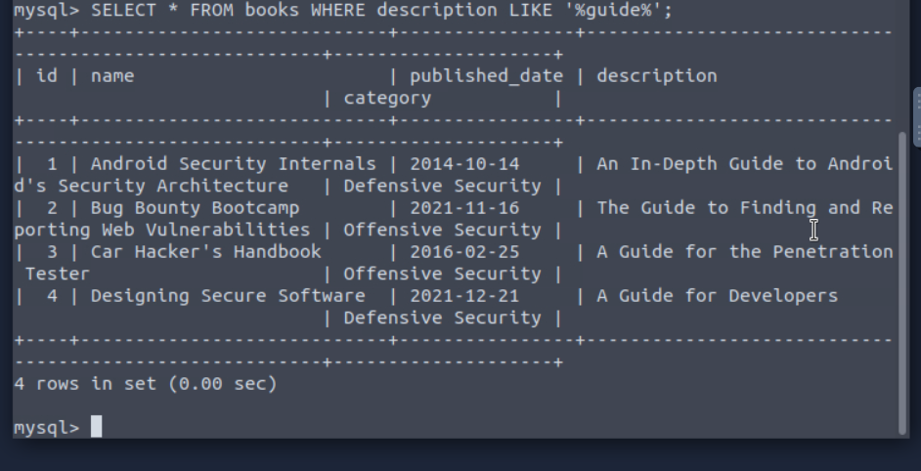The query above returns a list of records from the books filtered, but the ones using the WHERE clause that contains the word guide by using the LIKE operator.

AND Operator
The AND operator uses multiple conditions within a query and returns TRUE if all of them are true. 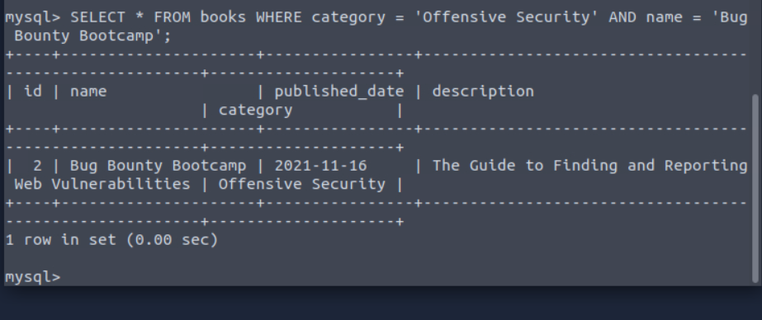
The query above returns the book with the name Bug Bounty Bootcamp, which is under the category of Offensive Security.

OR Operator
The OR operator combines multiple conditions within queries and returns TRUE if at least one of these conditions is true. 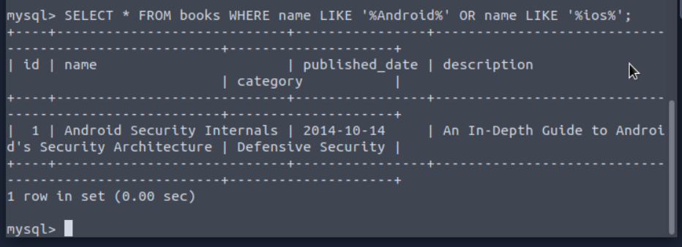
The query above returns books whose names include either Android or IOS.

NOT Operator
The NOT operator reverses the value of a boolean operator, allowing us to exclude a specific condition. 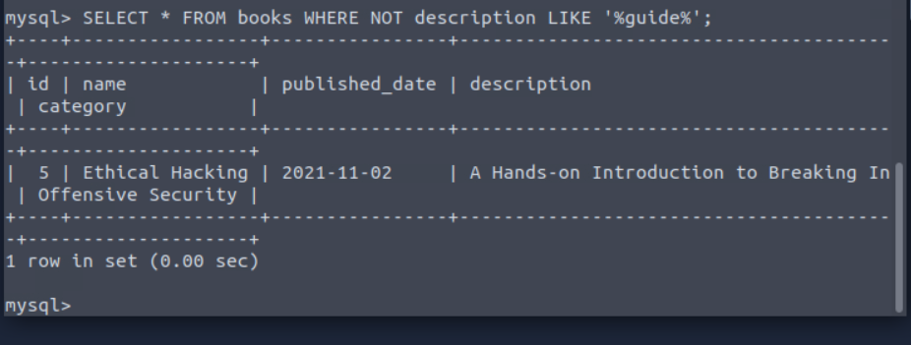
The query above returns results where the description does not contain the word guide.

BETWEEN Operator
The BETWEEN operator allows us to test if a value exists within a defined range. 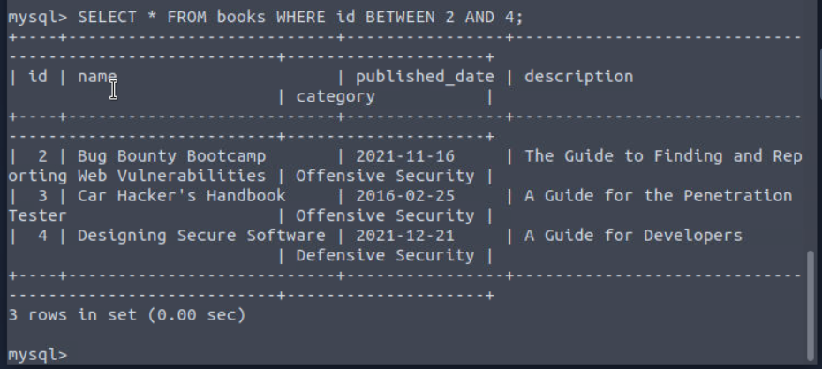The query above returns books whose id is between 2 and 4.

Comparison Operators
The comparison operators are used to compare values and check if they meet specified criteria.

Equal To Operator
The = (Equal) operator compares two expressions and determines if they are equal, or it can check if a value matches another one in a specific column.
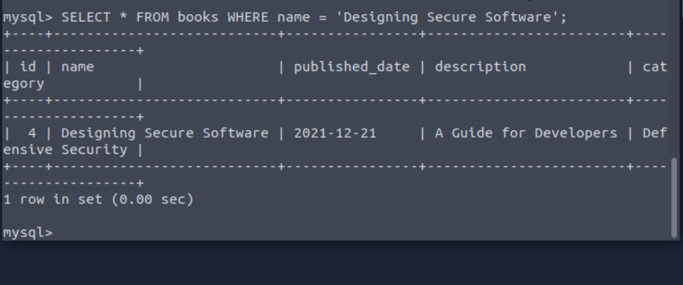
The query above returns the book with the exact name Designing Secure Software.

Not Equal To Operator
The != (not equal) operator compares expressions and tests if they are not equal; it also checks if a value differs from the one within a column. 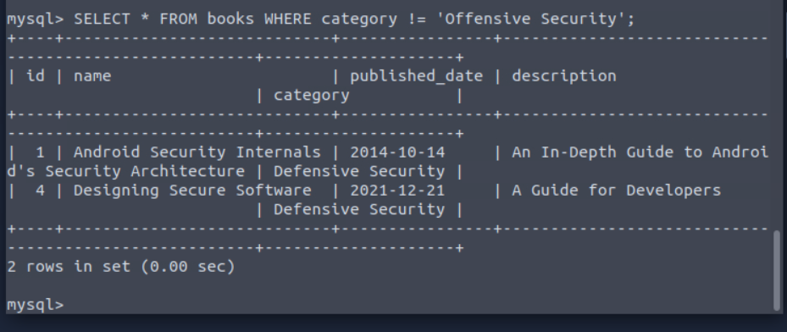
The query above returns books except those whose category is Offensive Security.

Less Than Operator
The < (less than) operator compares if the expression with a given value is lesser than the provided one. 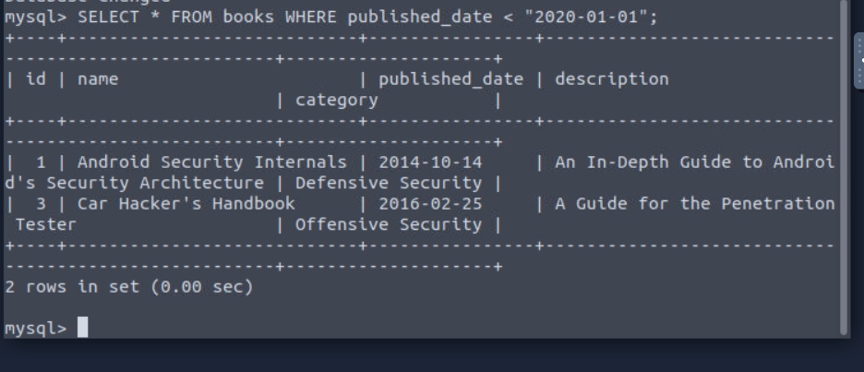The query above returns books that were published before January 1, 2020.

Greater Than Operator
The > (greater than) operator compares if the expression with a given value is greater than the provided one. 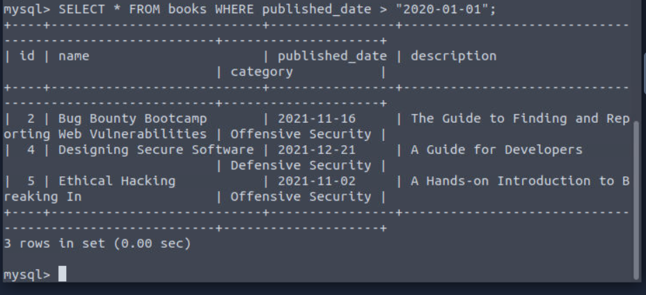The query above returns books published after January 1, 2020.

Less Than or Equal To and Greater Than or Equal To Operators
The <= (Less than or equal) operator compares if the expression with a given value is less than or equal to the provided one. On the other hand, The >= (Greater than or Equal) operator compares if the expression with a given value is greater than or equal to the provided one. Let's observe some examples of both below. 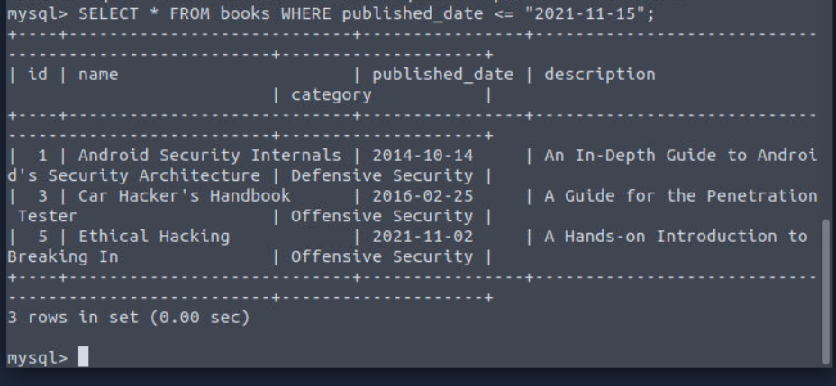The query above returns books published on or before November 15, 2021.
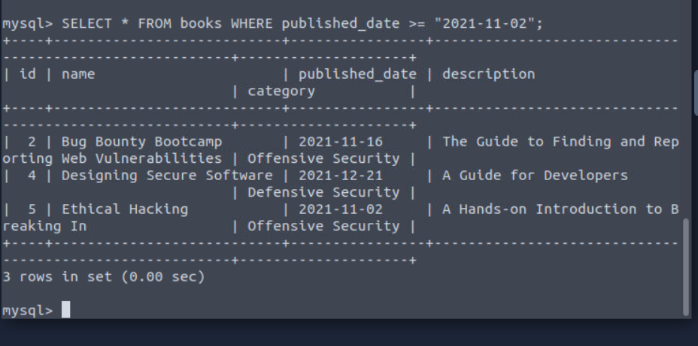The query above returns books that were published on or after November 2, 2021.

Practical:
Using the tools_db database, which tool falls under the Multi-tool category and is useful for pentesters and geeks? 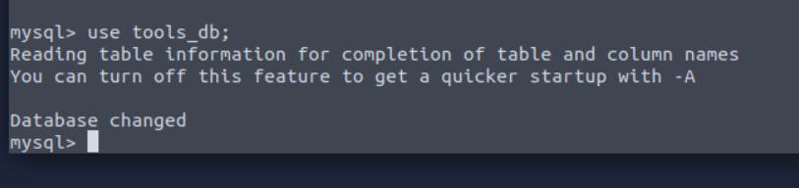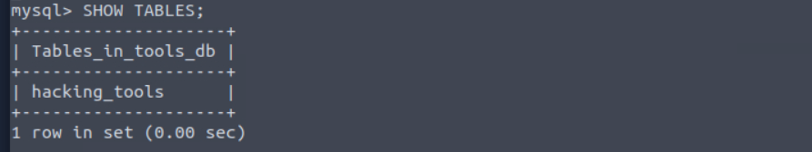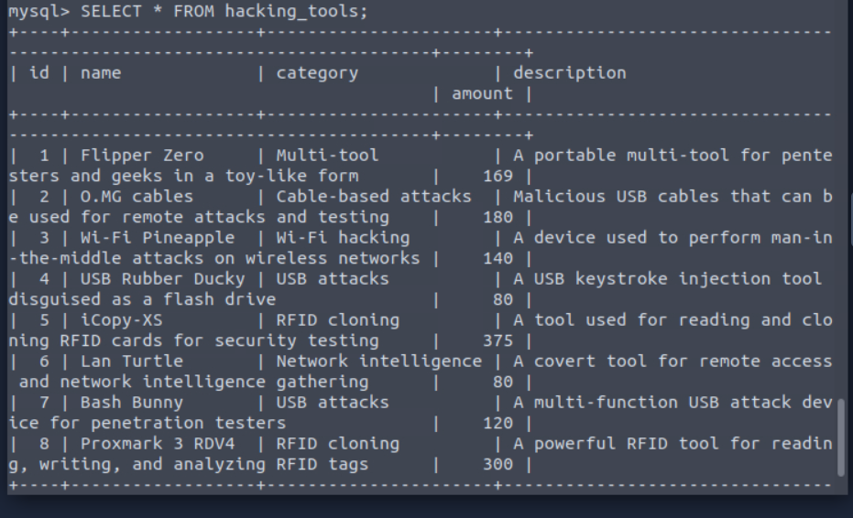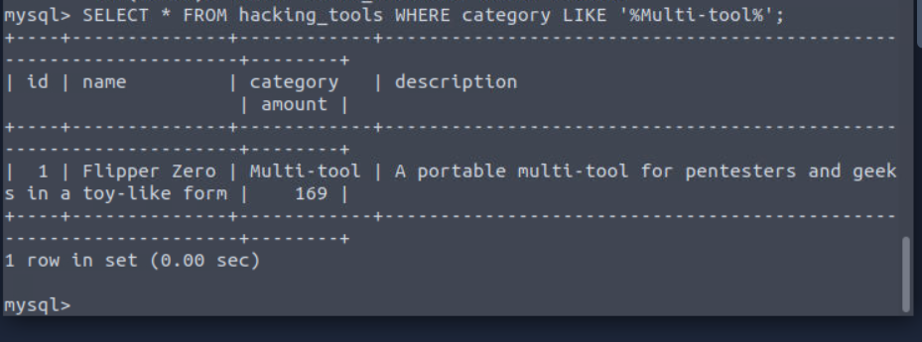

Using the tools_db database, what is the category of tools with an amount greater than or equal to 300?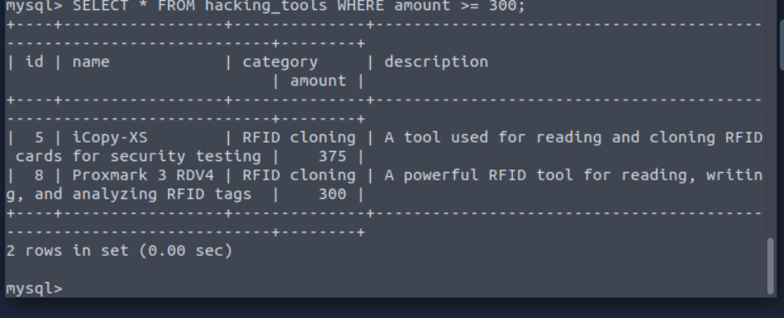
Using the tools_db database, which tool falls under the Network intelligence category with an amount less than 100? 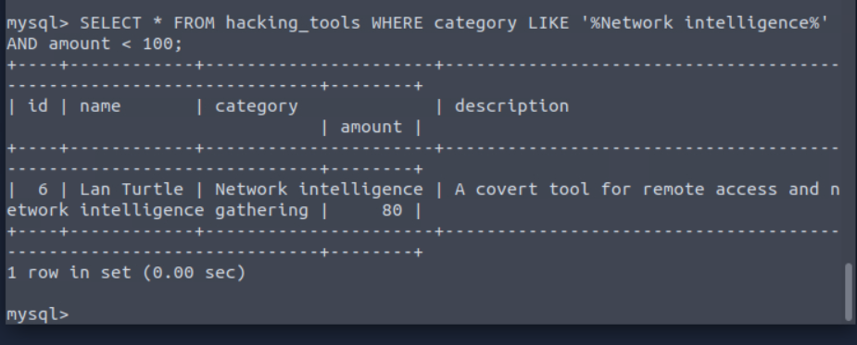

Functions
When working with Data, functions can help us streamline queries and operations and manipulate data. Let's explore some of these functions next.

String Functions
Strings functions perform operations on a string, returning a value associated with it.

CONCAT() Function
This function is used to add two or more strings together. It is useful to combine text from different columns. 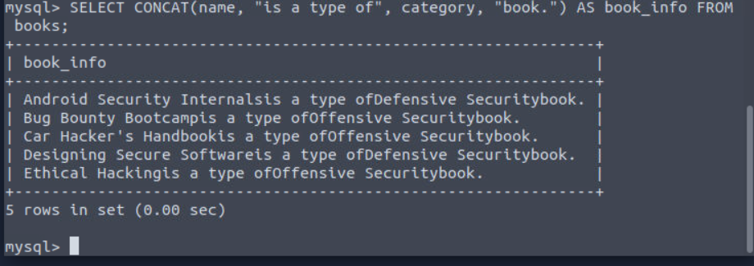
This query concatenates the name and category columns from the books table into a single one named book_info.

GROUP_CONCAT() Function
This function can help us to concatenate data from multiple rows into one field. Let's explore an example of its usage. 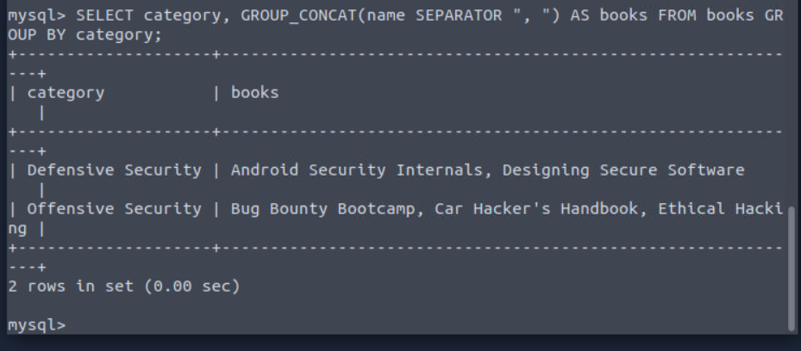
The query above groups the books by category and concatenates the titles of books within each category into a single string.

SUBSTRING() Function
This function will retrieve a substring from a string within a query, starting at a determined position. The length of this substring can also be specified. 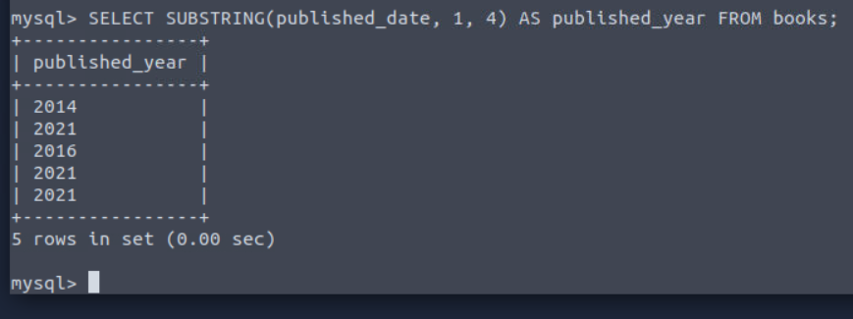
In the query above, we can observe how it extracts the first four characters from the published_date column and stores them in the published_year column.

LENGTH() Function
This function returns the number of characters in a string. This includes spaces and punctuation. We can find an example below. 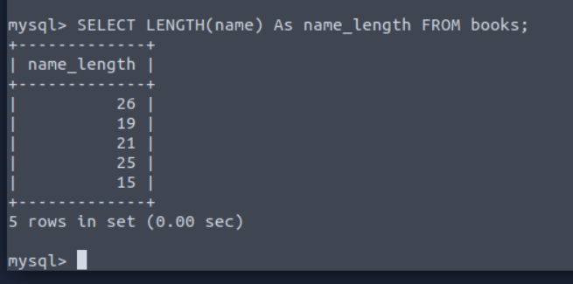
As we can observe above, the query calculates the length of the string within the name column and stores it in a column named name_length.

Aggregate Functions
These functions aggregate the value of multiple rows within one specified criteria in the query; It can combine multiple values into one result.

COUNT() Function
This function returns the number of records within an expression, as the example below shows. 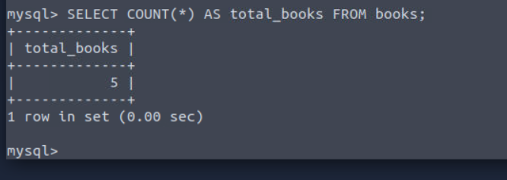
This query above counts the total number of rows in the books table. The result is 5, as there are five books in the books table, and it's stored in the total_books column.

SUM() Function
This function sums all values (not NULL) of a determined column.
Note: There is no need to execute this query. This is just for example purposes. 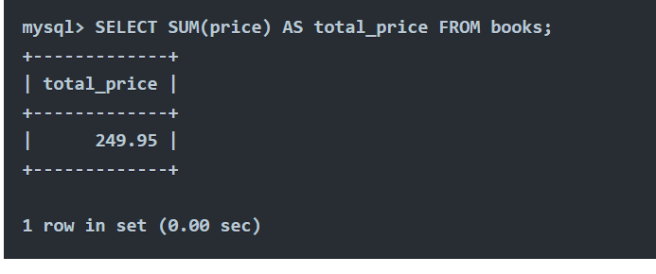The query above calculates the total sum of the price column. The result provides the aggregate price of all books in the column total_price.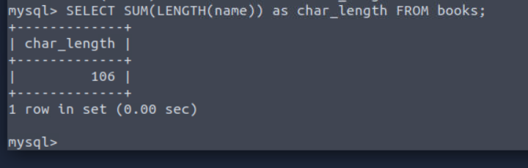

MAX() Function
This function calculates the maximum value within a provided column in an expression. 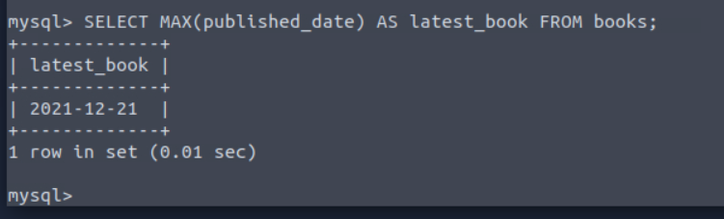The query above retrieves the latest publication (maximum value) date from the books table. The result 2021-12-21 is stored in the column latest_book.

MIN() Function
This function calculates the minimum value within a provided column in an expression. 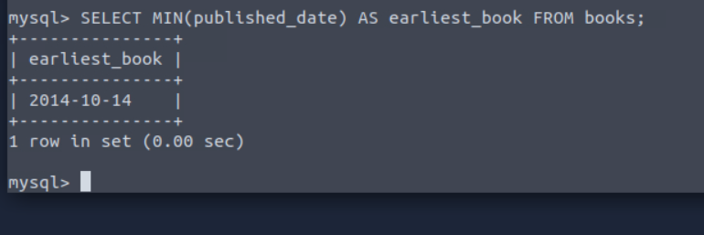The query above retrieves the earliest publication (minimum value) date from the books table. The result 2014-10-14 is stored in the earliest_book column.

Practical:
Using the tools_db database, what is the tool with the longest name based on character length? 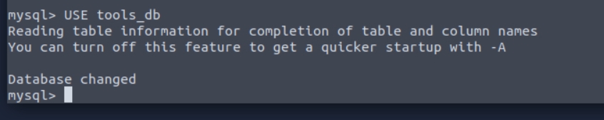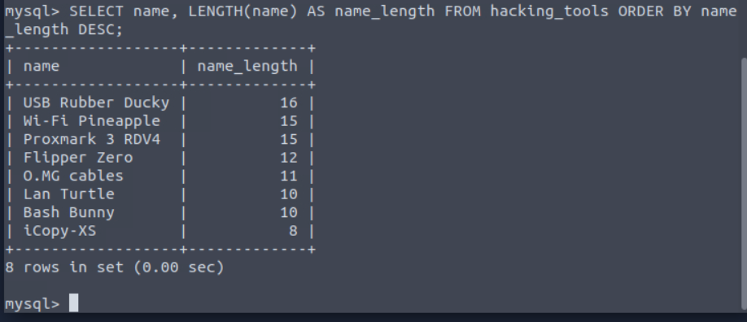
Using the tools_db database, what is the total sum of all tools? 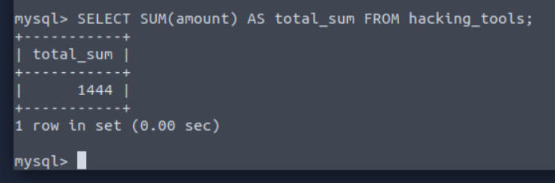

Using the tools_db database, what are the tool names where the amount does not end in 0, and group the tool names concatenated by " & ".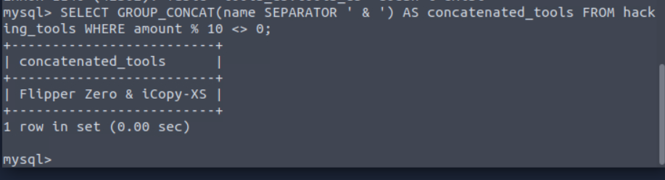

Conclusion:
Conclusion
Congratulations on completing SQL Fundamentals! This room has hopefully taught you the importance of databases in computing; with so many use cases (which we frequently interact with in our day-to-day lives), learning the fundamentals is a must if you want to pursue a career in cyber security. To round things off, let’s summarise everything that was covered in this room:
- Databases are collections of organised data or information that are easily accessible and can be manipulated or analysed.
- The two primary types of databases are relational databases (used to store structured data) and non-relational databases (used to store data in a non-tabular format).
- Relational databases are made up of Tables, columns and rows. Primary keys can ensure a record is unique within a table, and foreign keys can allow for a relationship/connection to be made between two (or more) tables.
- SQL is an easy-to-learn programming language that can be used to interact with relational databases.
- Database and Table statements can be used to create/manipulate databases and tables.
- CRUD Operations (INSERT, SELECT, UPDATE and DELETE) can be used to manage data in a database.
- In SQL, we can use clauses to define how data should be retrieved, filtered, sorted, or grouped.
- The efficient use of operators and functions can help us filter and manipulate data in SQL.
That wraps up this room. Click the button below to complete the room!

